
THE PRESIDENT’S OFFICE
REGIONAL ADMINISTRATION AND LOCAL GOVERNMENT
ARUSHA CITY COUNCIL
FORM TWO MOCK EXAMINATION, SEPTEMBER 2019

HISTORY

INSTRUCTIONS: Time: 2 $\frac{1}{2}$Hours

- This paper consists of section A, B and C
- Answer all questions in sections A and B and TWO questions from section C
- All writings must be in Blue or Black ink
- Write your name on every page of your answer sheet.

SECTION A: (30 MARKS)
- For each of the items (i) to (x), choose the correct answer from among the given alternatives and write its letter in the space provided
- The earliest people to live in the present Cape Province of South Africa were the:
- Xhosa and Bushmen
- Khoikhoi and the Hottentos
- San and the Xhosa
- Herero and the Hottentos
- One of the characteristics of feudalism was
- Enslavement of the poor people
- The sale of slaves
- Land was in hands of few individuals
- The children of the servants were taken away
- Gao was a trading center which developed into a large empire known as
- Songhai
- Ghana
- Mali
- No correct answer
- The Barbers were famous traders in
- Inter-continental trade
- East African long distance trade
- The trans-Saharan trade
- The west African slave trade
- The nickname of Zinjanthroupus was
- The upright man
- The giant man
- The dwarf man
- The nutcracker man

- The commercial contact which linked between East African coast and Asia began in

- The 15th century
- The 13th century
- The 7th century
- The 16th century

- The biblical notion that God created human kind and all other modern living creatures in a single week of creation was challenged by:

- Chancellor Bismarck
- David Livingstone
- Charles Darwin
- Mary Leakey

- Ubugabire system in the interlecustrine region the power of the ruler was usually based on
- Cattle ownership
- Land ownership
- Land and cattle ownership
- Military and land ownership
- The source of historical information which contain remains that show man’s physical development activities and tools he used is

- Archives
- Museum
- Archeology
- Historical site

- The Maasai did not have chiefs because they ………….
- Believed in god as their only chief
- Did not know that chiefs were good
- Trusted their warriors
- Moved in different directions looking for pasture
I | II | III | IV | V | VI | VII | VIII | IX | X
- Match the following items in List A with those in List B by writing the correct letter below the corresponding question number in the table provided
LIST A | LIST B
- Monsoon winds  - Productive forces  - Example of historical sites  - Zwangendaba  - Feudal mode of production which developed in Karagwe  - Matrilineal societies in East Africa  - Political and religious leader among the Maasai  - The great Zulu warrior who established Zulu empire  - Closure of slave market in Zanzibar  - The Periplus of Eritrean sea | - A Greek guiding book to East Africa  - The Laibon  - 1822  - Ubugabire  - 1873  - Producers, skills, experience and level of science and technology in a society  - The Sukuma and Hehe  - Bagamoyo, Kilwa and Isimila  - Carried ships from East Africa to Asia and back  - Moran  - Kalenga, Bujora and Bagamoyo  - Carried ships from South Africa to East Africa  - Mzilikazi  - Nyarubanja  - Forces that bind the societies together in production  - Makonde and Mwera  - Ngoni migration  - Shaka

i | ii | iii | iv | v | vi | vii | viii | ix | x

- In each of the following statement, write T if the statement is TRUE and F if the statement is FALSE
- Microlith is a term used by archeologists to refer to the sharper and lighter tools
- Mogadishu, Kilwa, Lamu and Timbuktu were some of the city states along the coast of East Africa
- Oman Arabscooperated with the people of East African city states to remove the Portuguese from the north of Ruvuma river
- Trickery method was among the way used to obtain slaves in East Africa
- Traders from the Far East who came to the coast of East Africa included the Indonesians, Indians and Chinese
- African societies had no political organization before the coming of foreigners
- An economic system in which the major means of production are owned by the majority is slavery
- Karagwe, Ugweno and Engaruka were among the famous iron centers in East Africa
- Non – centralized statesare also known as kingdoms
- The Ngoni migration contributed to the formation of states in North – Eastern Tanganyika
I | II | III | IV | V | VI | VII | VIII | IX | X

SECTION B :(40 MARKS)
- Briefly explain the following historical terms:

- Mixed farming
- Handcraft industries
- Age-set-system
- The evolution of man
- Indian Banyans

- Arrange the following sentences in a chronological order from the first to the last by using ROMAN NUMBERS (I – V)
- The Oman Sultanate greatly stimulated the expansion of trade in East Africa
- Introduction of clove plantations in Zanzibar had an impact on African masses who were robbed of their best arable land turned into serfs and tenants
- This was after Seyyid Said had shifted his capital from Muscat Oman to Zanzibar in 1840
- Effective control of Oman sultanate in East Africawas established during the second half of the 19th century
- This was a period which he was able to establish more uniform political control along the coast by appointing Liwalis to govern the city states on his behalf
i | ii | iii | iv | v

- Write the missing historical facts in the following gaps
- The war fought by the Boers against the British was known as……………….
- …………………. was the name given to the people who mostly dealt with iron working industries in Africa.
- The Dutch Settlers were known as……………………………………………………
- The name given to the Holy Islamic war was……………………………………….
- The first European nation to industrialize and abolish slave trade was the…………………………………………………….
- A group of related families whom their descendants are from their common ancestors are known as …………………………………………………..
- List the missing historical sites labeled (i) to (v)
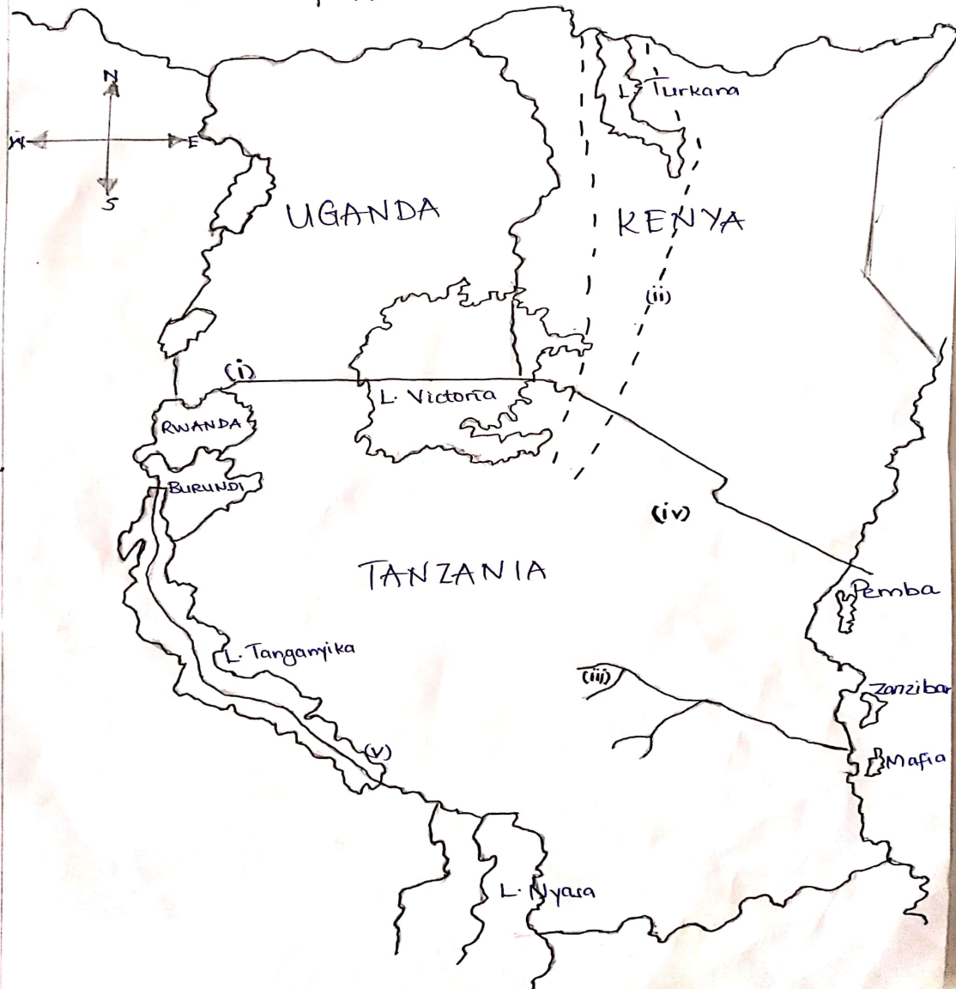

SECTION C: (30 MARKS)
In this section choose only TWO questions
- What are the advantages and disadvantages of Historical sites? Write THREE points each
- Explain about Triangular Trade by using the following guidelines
- Meaning
- Participants
- The period it was conducted
- Commodities which were exchanged
- The impact of Triangular Trade
- What were effects of economic interaction in pre-colonial African communities?
Give six points.

…………………………………………………………………………………………………………………………………………………………………………………………………………………………………………………………………………………………………………………………………………………………………………………………………………………………………………………………………………………………………………………………………………………………………………………………………………………………………………………………………………………………………………………………………………………………………………………………………………………………………………………………………………………………………………………………………………………………………………………………………………………………………………………………………………………………………………………………………………………………………………………………………………………………………………………………………………………………………………………………………………………………………………………………………………………………………………
……………………………………………………………………………………………………………………………………………………………………………………………………………………………………………………………………………………………………………………………………………………………………………………………………………………………………………………………………………………………………………………………………………………………………………………………………………………………………………………………………………………………………………………………………………………………………………………………………………………………………………………………………………………………………………………………………………………………………………………………………………………………………………………………………………………………………………………………………………………………………………………………………………………………………………………………………………………………………………………………………………………………………………………………………………………………………………………………………………………………………………………………………………………………………………………………………………………………………………………………………………………………………………………………………………………………………………………………………………………………………………………………………………………………………………………………………………………………………………………………………………………………………………………………………………………………………………………………………………………………………………………………………………………………………………………………………………………………………………………………………………………………………………………………………………………………………………………………………………………………………………………………………………………………………………………………………………………………………………………………………………………………………………………………………………………………………………………………………………………………………………………………………………………………………………………………………………………………………………………………………………………………………………………………………………………………………………………………………………………………………………………………………………………………………………………………………………………………………………………………………………………………………………………………………………………………………………………………………………………………………………………………………………………………………………………………………………………………………………………………………………………………………………………………………………………………………………………………………………………………………………………………………………………………………………………………………………………………………………………………………………………………………………………………………………………………………………………………………………………………………………………………………………………………………………………………………………………………………………………………………………………………………………………………………………………………………………………………………………………………………………………………………………………………………………………………………………………………………………………………………………………………………………………………………………………………………………………………………………………………………………………………………………………………………………………………………………………………………………………………………………………………………………………………………………………………………………………………………………………………………………………………………………………………………………………………………………………………………………………………………………………………………………………………………………………………………………………………………………………………………………………………………………………………………………………………………………………………………………………………………………………………………………………………………………………………………………………………………………………………………………………………………………………………………………………………………………………………………………………………………………………………………………………………………………………………………………………………………………………………………………………………………………………………………………………………………………………………………………………………………………………………………………………………………………………………………………………………………………………………………………………………………………………………………………………………………………………………………………………………………………………………………………………………………………………………………………………………………………………………………………………………………………………

END

